**Ihor Sviatskyi**

**Odessa, Ukraine**

**Mobile:** 0989541848

**Skype:** Ingwar Sv

**E-mail:** [sviatskyi@gmail.com](mailto:sviatskyi@gmail.com)

**Telegram:** @IngwarSv

**CHESS**

(multiplayer chess game for two players)

1. Application consists of 7 scenes and tests for main logic:

* GameMenu scene;
* MainGame scene (player vs player);
* SaveGame scene;
* LoadGame scene;
* CustomGame scene;
* GameSettings scene;
* QuitGame scene.

1. App validates all moves (if a player wants to make a move that is not allowed by chess rules, app blocks such attempt and shows corresponding notification).
2. App correctly handles such chess rules:

* castling;
* *En passant* move;
* promotion (to Queen, Bishop, Knight, Rook);
* check;
* checkmate;
* draw (stalemate, impossibility of checkmate (two kings left, king and knight versus king, king with/without bishop versus king and bishop/bishops on the same color);

1. Games can be saved and resumed after loading (including information for castling, *En passant,* previous moves and used time for both players).
2. CustomGame scene allows to deploy figures manually and start new game.
3. GameSettings scene provides management for music / sounds volume.
4. Couldn’t connect Google tests to solution properly *(placed topic on* [*https://discuss.cocos2d-x.org*](https://discuss.cocos2d-x.org/)*)*, so I implemented own tests for main game logic (needs to “#define PERFORM_TESTS 1” in *AppDelegate.cpp* to run and in *NewGameScene.cpp* to show result in scrollView).

IDE: Microsoft Visual Studio 2019 Community edition

Cocos2d-x-3.17.2

<https://github.com/IngwarSV/Chess__Cocos2d-x>

My first independent project in Cocos2d-x, so there are a lot of drawbacks)

**Screenshots**

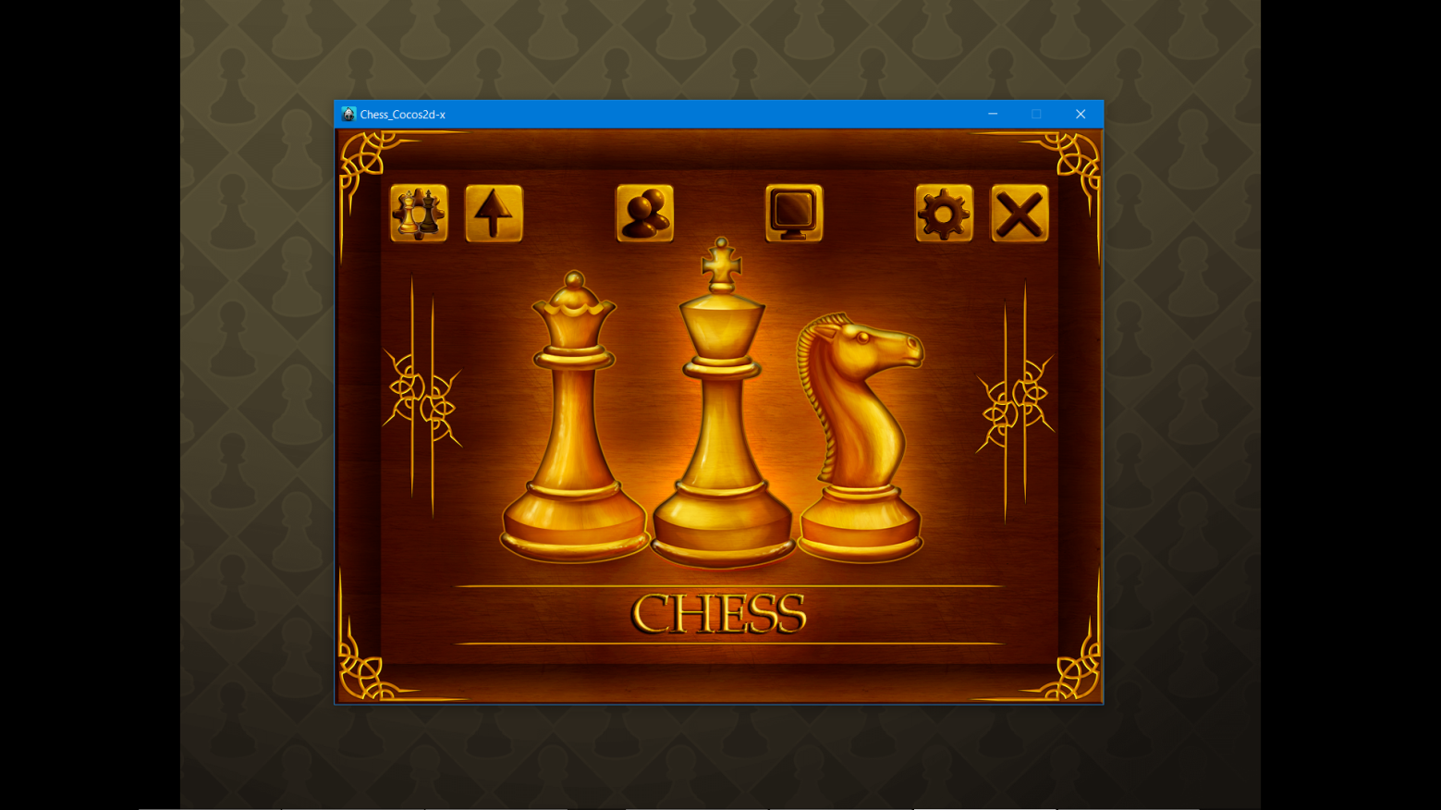

**GameMenu scene**

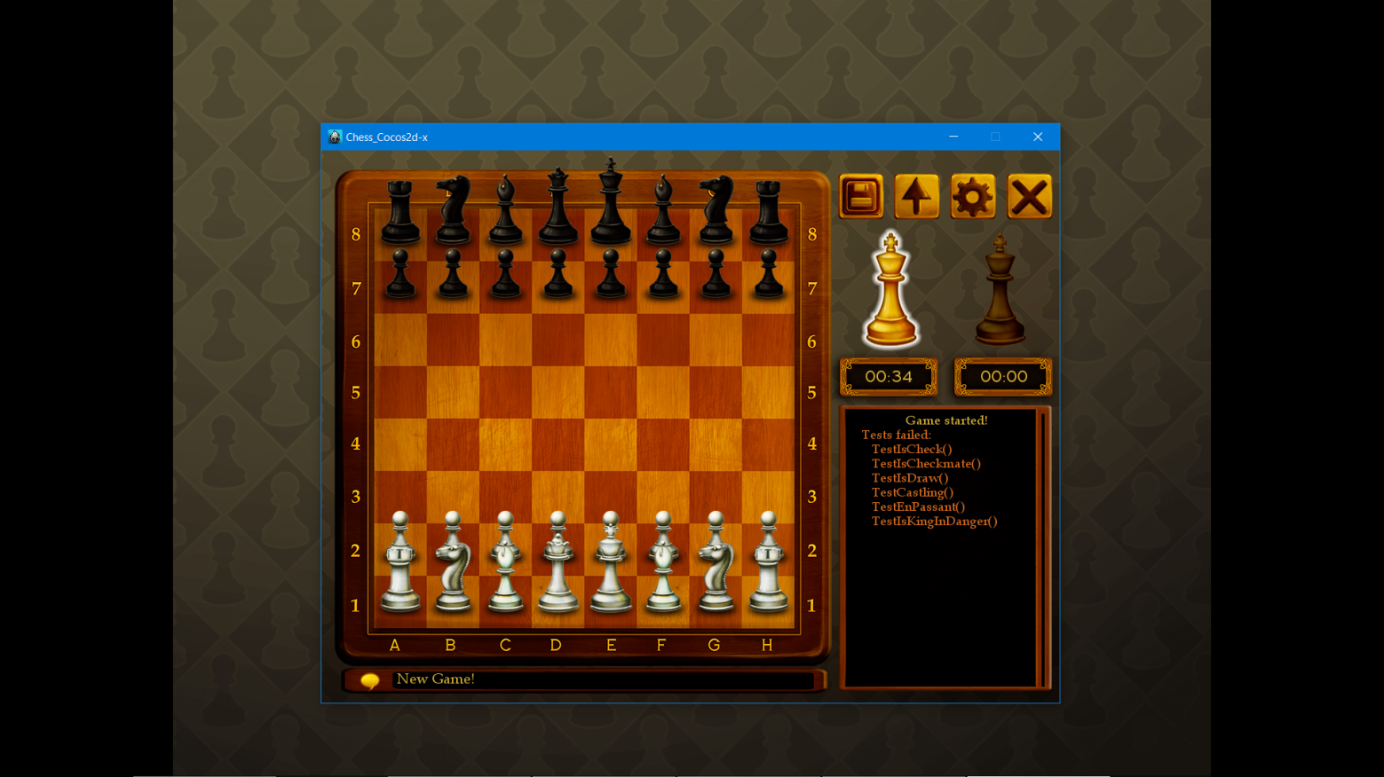

**NewGame scene, tests intentionally failed**

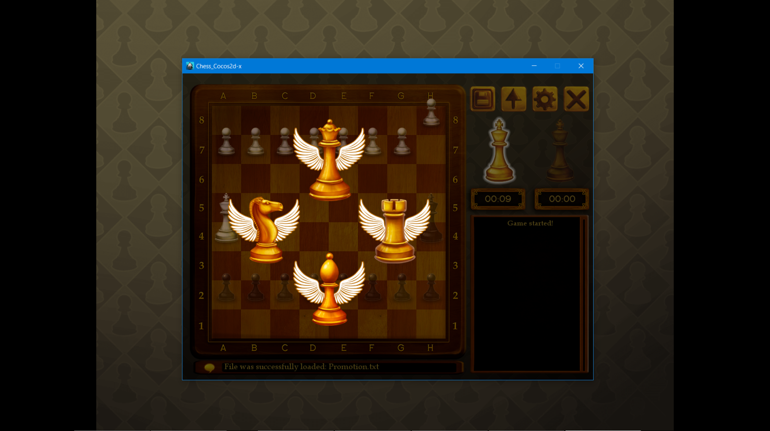

**NewGame scene, promotion layer**

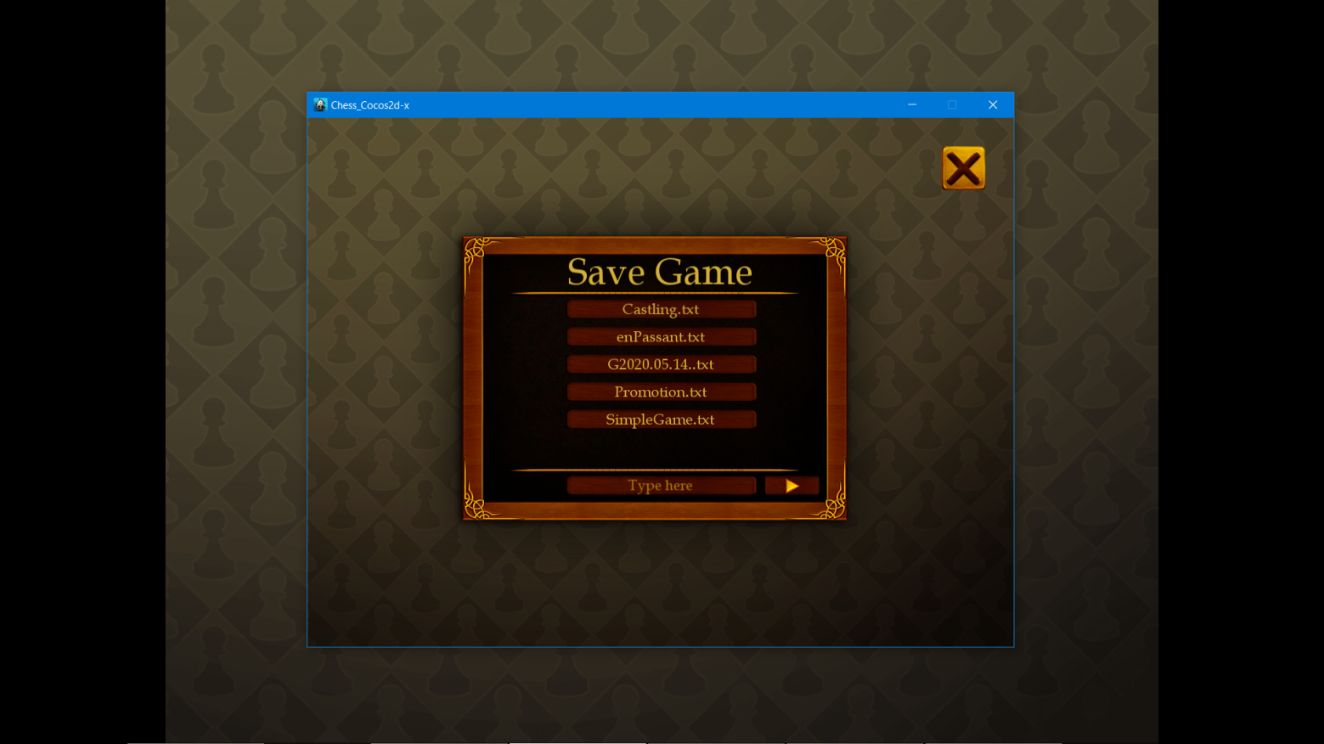

**SaveGame scene (existing files are shown in scrollView)**

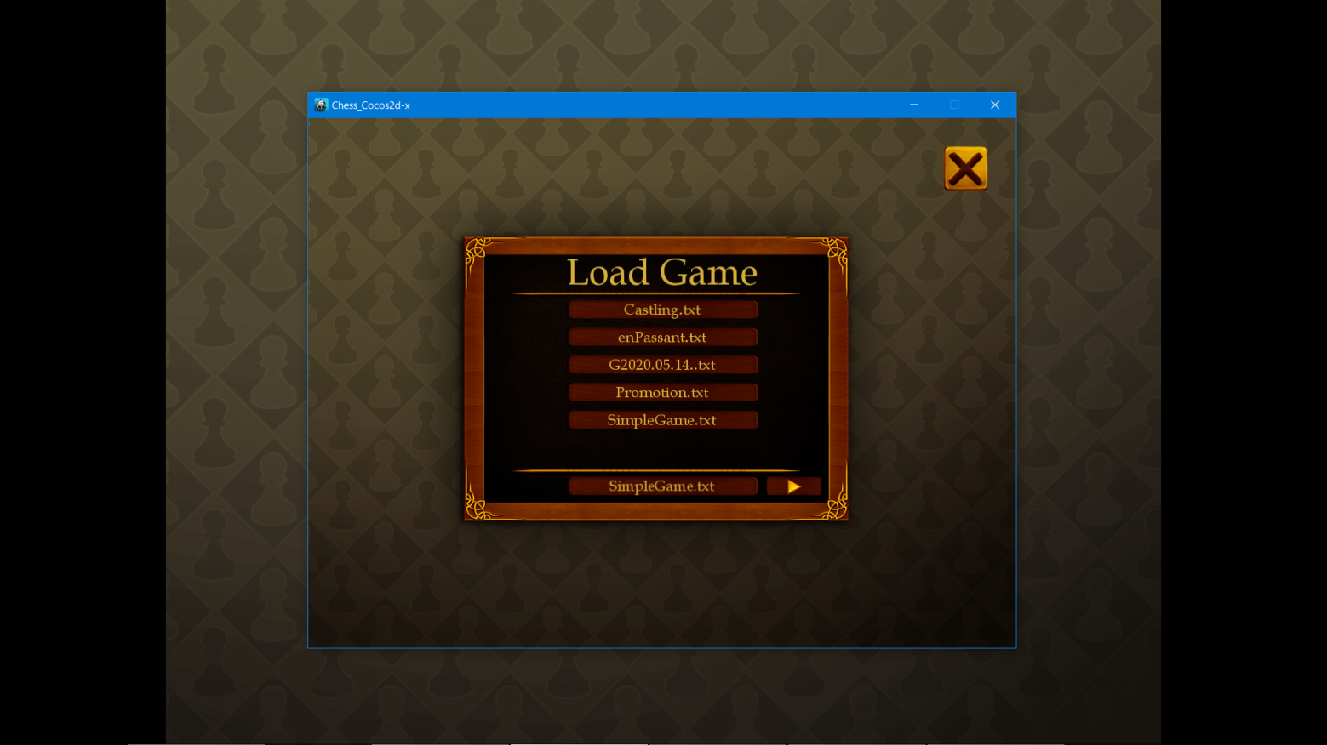

**LoadGame scene (buttons with existing filesNames)**

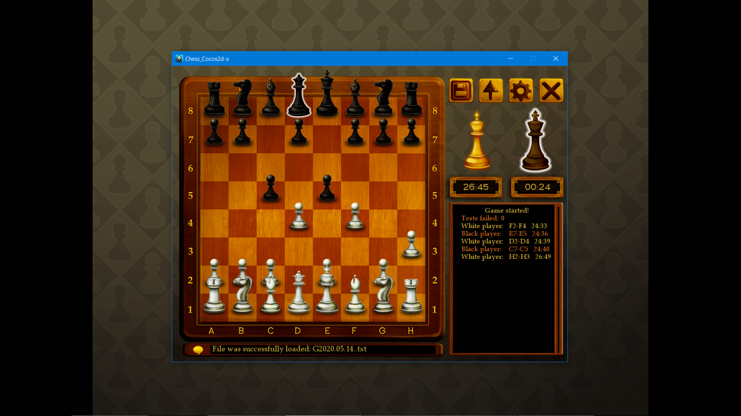

**NewGame scene, game is loaded**

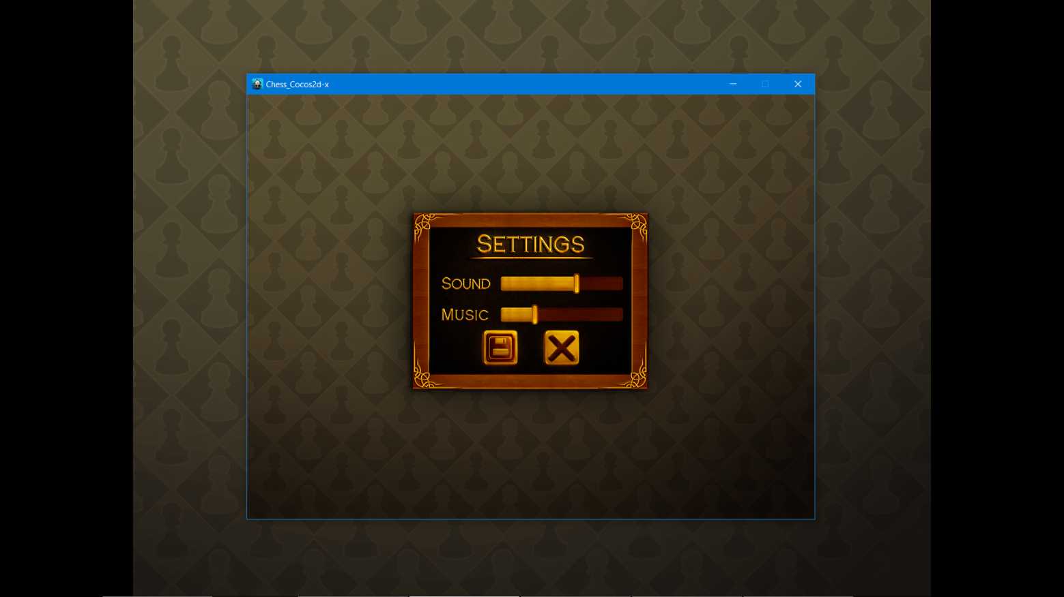

**GameSettings scene**

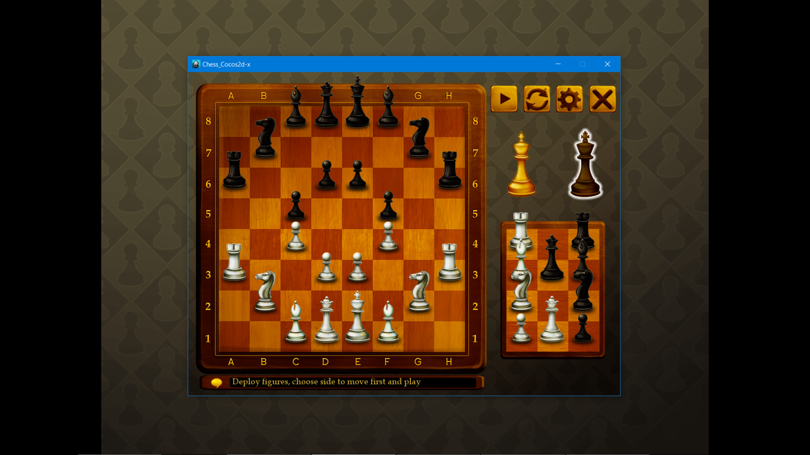

**CustomGame scene**

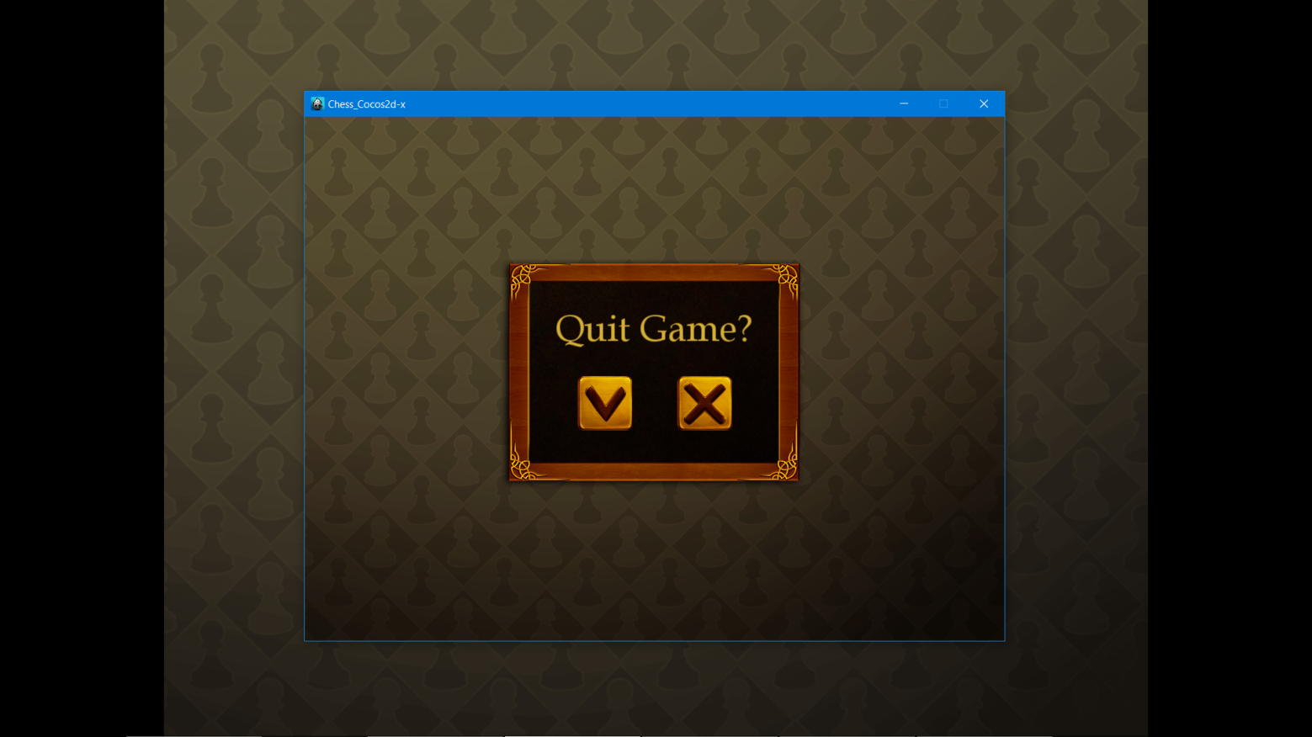

**QuitGame scene**

**Thank you for your attention!**